STEP 1: CREATE THE FILE NEW FILE
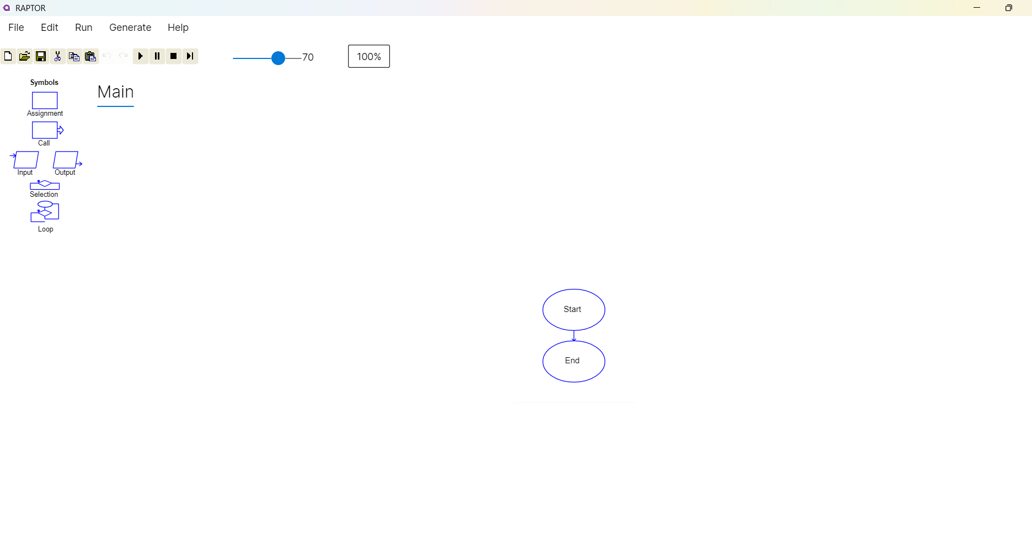
STEP 2:ADD THE INPUT AND ASSINGNMENT SYMBOLS
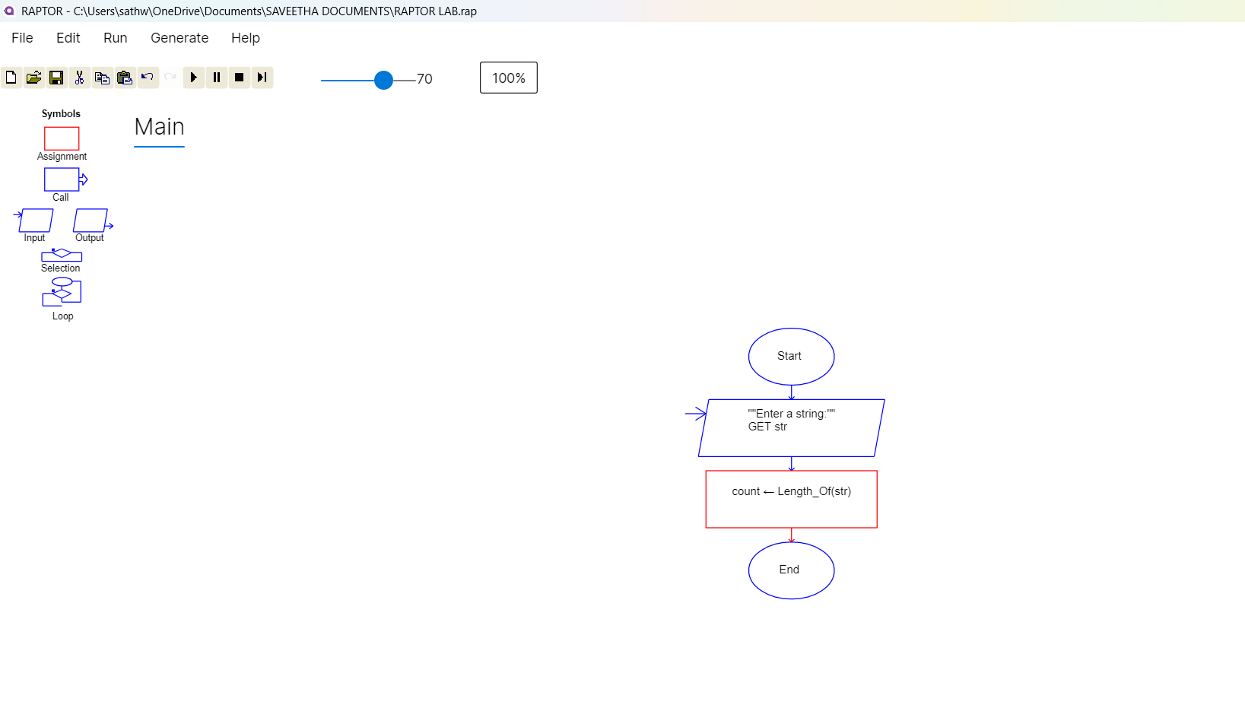

STEP 3:FIND OUTPUT AND GET THE COMMAND INSIDE IT
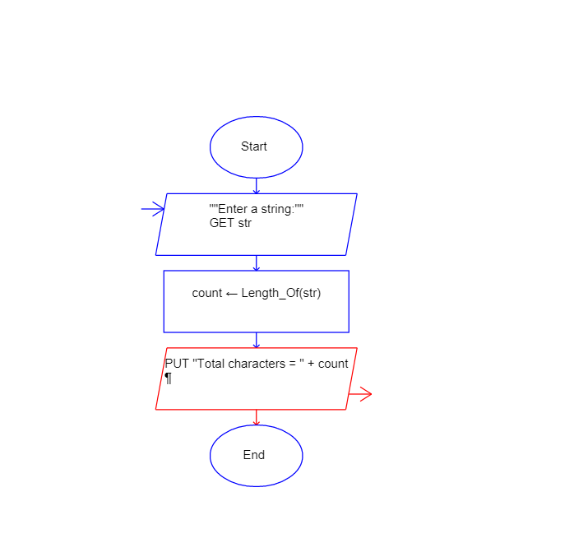
STEP 4:ENTER THE INPUT STRING IT CALCULATE TOTAL CHARACTER


